Assignment 4

1.1)

stdnum -> name, address, phoneNum, email

stdnum, email -> name, address, phoneNum

phoneNum -> area_code, office_code, station_code

area_code, office_code -> city

postcode -> city

period, room_num, term -> course_num

room_num -> building

stdnum, course_num -> grade

1.2)

[stdnum | name, address, phoneNum, email]

[phoneNum | area_code, office_code, station_code]

[area_code, office_code | city]

[postcode | city]

[period, room_num, term | course_num]

[room_num | building]

[stdnum, course_num | grade]

[period, postcode, room_num, stdnum, term | ]

1.3)

stdnum -> name, address, phoneNum, email

phoneNum -> area_code, office_code, station_code

area_code, office_code -> city

postcode -> city

period, room_num, term -> course_num

room_num -> building

stdnum, course_num -> grade

FD Sets are Equivalent

2.1)

MovieTitle, Director -> Producer

ActorName -> Phone, Address, AgentName

SPTitle, Author -> SPTitle, Author

Scene#, SPTitle, Author -> StoryLocation, FilmLocation

Take#, Scene#, SPTitle, Author -> Date, Time

Scene# ActorName, SPTitle, Author -> temp

MovieTitle, Director -> SPTitle, Author

2.2)

MovieTitle, Director -> Producer

ActorName -> Phone

ActorName -> Address

ActorName -> AgentName

Scene#, SPTitle, Author -> StoryLocation

Scene#, SPTitle, Author -> FilmLocation

Take#, Scene#, SPTitle, Author -> Date

Take#, Scene#, SPTitle, Author -> Time

Scene#, ActorName, SPTitle, Author -> temp

MovieTitle, Director -> SPTitle

MovieTitle, Director -> Author

2.3)

[MovieTitle, Director | Producer, SPTitle, Author]

[ActorName | Phone, Address, AgentName]

[Scene#, SPTitle, Author | StoryLocation, FilmLocation]

[Take#, Scene#, SPTitle, Author | Date, Time]

[Scene#, ActorName, SPTitle, Author | temp]

[ActorName, Director, MovieTitle, Scene#, Take# | ]

3.1)

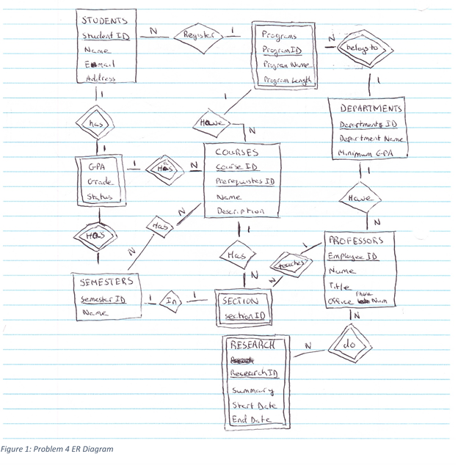

3.2)

StudentID, Name, Email, Address, Grade, Status, DepartmentID, DepartmentName, MinGPARequired, ProgramID, ProgramName, ProgramLength, CourseID, PrerequisitesID, CourseName, CourseDescription, SectionID, SemesterID, SemesterName, EmployeeID, EmployeeName, EmployeeTitle, EmployeeOfficeNum, ResearchID, ResearchName, ResearchSummary, ResearchStartDate, ResearchEndDate

3.3)

StudentID -> Name, Email, Address, ProgramID

StudentID, CourseID, SemesterID -> Grade,Status

DepartmentID -> DepartmentName, MinGPARequired

DepartmentID, ProgramID -> ProgramName, ProgramLength

CourseID, PrerequisitesID -> DepartmentID, ProgramID, CourseName, CourseDescription

CourseID, SectionID -> EmployeeID, SemesterID

SemesterID -> SemesterName

EmployeeID -> DepartmentID, EmployeeName, EmployeeTitle ,EmployeeOfficeNum

EmployeeID,ResearchID -> ResearchName, ResearchSummary, ResearchStartDate, ResearchEndDate

StudentID -> ProgramID,ProgramName,ProgramLength

ProgramID -> CourseID, PrerequisitesID, DepartmentID, ProgramID, CourseName, CourseDescription

CourseID,PrerequistesId -> SemesterID,SemesterName

DepartmentID -> EmployeeID, DepartmentID, EmployeeName, EmployeeTitle, EmployeeOfficeNum

3.4)

[StudentID | Name,Email,Address,ProgramID,Grade,Status]

[DepartmentID | DepartmentName, MinGPARequired, EmployeeID, EmployeeName, EmployeeTitle, EmployeeOfficeNum]

[CourseID,PrerequisitesID | ProgramID,SemesterID]

[CourseID,SectionID | EmployeeID,SemesterID]

[SemesterID | SemesterName]

[EmployeeID,ResearchID | ResearchName, ResearchSummary, ResearchStartDate, ResearchEndDate]

[ProgramID | CourseID, PrerequisitesID, DepartmentID, CourseName, CourseDescription, ProgramName, ProgramLength]

[ResearchID, SectionID, StudentID | ]